Project Report

Zomato Data Analysis Project Report

Name : Atharav Keshav Kale
Project Name : Zomato Data Analysis using Power BI & Excel
Date Of Submission : 28/01/ 2026
Techonlogy Used : Power BI ,SQl

1. Introduction
This project focuses on analyzing Zomato restaurant data using modern data analysis tools.
The main aim is to understand customer preferences, popular restaurant categories,
and location-wise distribution. This helps businesses improve their services and increase profits.
In today’s digital world, online food delivery platforms play a very important role in connecting customers with restaurants. Zomato is one of the leading food delivery and restaurant discovery platforms that provides information about restaurants, menus, ratings, reviews, and locations. Due to the large amount of data generated every day, it has become necessary to analyze this data to understand customer preferences and market trends.
This project focuses on analyzing Zomato restaurant data using tools such as Excel and Power BI. The main objective of this project is to study customer behavior, identify popular restaurant categories, and analyze location-wise restaurant distribution. By using data visualization techniques like charts and dashboards, complex data is converted into simple and meaningful information.
The analysis helps restaurant owners, managers, and customers in making better decisions. Restaurant owners can improve their services and marketing strategies, while customers can easily find suitable restaurants based on ratings, cost, and location. Overall, this project demonstrates how data analysis can be used effectively to support business growth and improve customer satisfaction

2. Dataset Description
The dataset was collected from Zomato and contains information such as restaurant name,
category, location, rating, votes, and average cost. This data is useful for identifying
market trends and customer behavior. Proper cleaning and preprocessing were done
before analysis.
The dataset used in this project is collected from the Zomato platform and contains detailed information about various restaurants. It includes important attributes such as restaurant name, location, category, cuisine type, ratings, number of votes, average cost for two people, and online delivery availability. This data helps in understanding the overall restaurant market and customer preferences.
Before starting the analysis, the dataset was carefully examined and cleaned. Missing values, duplicate records, and incorrect entries were removed to improve data quality. Data preprocessing techniques such as filtering, sorting, and formatting were applied using Excel and Power BI. This ensured that the dataset was accurate and ready for analysis.
The dataset is structured in a tabular format, where each row represents a restaurant and each column represents a specific feature related to that restaurant. This organized structure makes it easy to perform various types of analysis, such as category-wise comparison, location-wise distribution, and rating-based performance evaluation.
By using this dataset, meaningful insights were generated to understand market trends, customer behavior, and business opportunities. The dataset plays a vital role in achieving the objectives of this project and forms the foundation for all analysis and visualizations.

3. Data Analysis and Graphs
Data analysis was performed using Excel and Power BI. Charts and graphs were created
to represent trends clearly. Category-wise and location-wise analysis was done.
These visualizations help in better decision making.
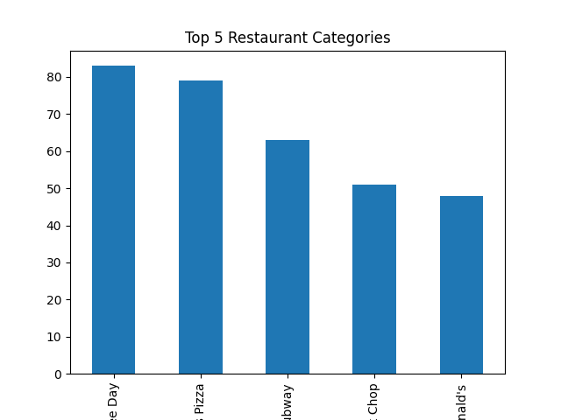

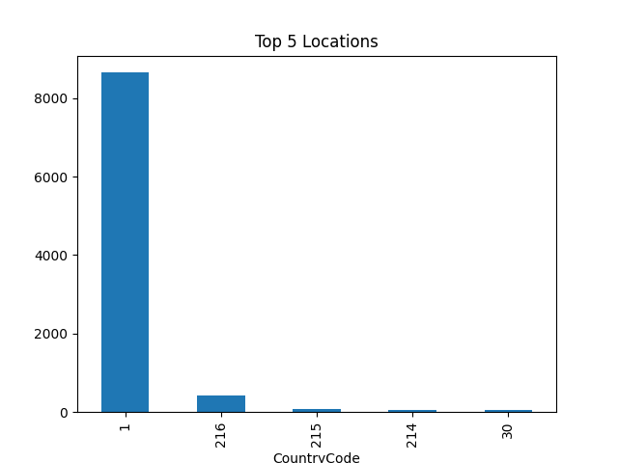

4. Conclusion
This project successfully analyzed Zomato data and provided useful insights.
It helps restaurant owners and customers make better choices.
Future work can include customer reviews and sentiment analysis.
Through proper data cleaning and preprocessing, the quality and accuracy of the dataset were improved. This ensured that the analysis results were reliable and useful for decision-making. Various charts, graphs, and dashboards were created to present complex data in a simple and easy-to-understand manner. These visualizations made it possible to identify important trends and patterns.
The analysis revealed that certain locations have a higher concentration of popular restaurants, while some categories are more preferred by customers. Ratings and customer reviews played a significant role in determining restaurant popularity. It was also observed that restaurants offering online delivery and affordable pricing tend to attract more customers.
This project highlights the importance of data-driven decision-making in today’s competitive business environment. Restaurant owners can use these insights to improve service quality, menu planning, pricing strategies, and marketing efforts. Customers can also benefit by choosing better restaurants based on ratings, cost, and location.

